**LOVELY PROFESSIONAL UNIVERSITY**

CSE 326

PROJECT REPORT

***ON***

HOSTEL ACCOMODATION FOR THE STUDENTS OF LPU

SUBMITTED TO: MANUBALI

GROUP MEMBERS: NAVEEN KAMMARI(60)

ABHISHE KR AZAD(61)

LAXMAN KUMAR (62)

OUTLINE

* INTRODUCTION
* CONCEPTS USED
* MODULES
* WORK DONE BY TEAM MEMBERS
* PROJECT IMPLEMENTATION
* SCREENSHOTS OF WEBSITE
* CONCLUSIONS
* BIBLIOGRAPHY

***INTRODUCTION***

### “HOSTEL MANAGEMENT SYSTEM” is WEBPAGE developed for managing various activities in the hostel. For the past few years the numbers of educational institutions are increasing rapidly. Thereby the numbers of hostels are also increasing for the accommodation of the students studying in this institution. And hence there is a lot of strain on the person who are running the hostel and software’s are not usually used in this context. This particular project deals with the problems on managing a hostel and avoids the problems which occur when carried manually.

Identification of the drawbacks of the existing system leads to the designing of computerized system that will be compatible to the existing system with the system which is more users friendly and more GUI oriented.

**CONCEPTS USED**

The supplementary specification applies to hostel management system. This specification defines the non-functional requirement of the system such as:

**Functionality:**

Since it stand alone application, one or more user may use it at a time.

**Usability:**

Desktop interface

Windows 98/2000/XP/7/8

**Technology:**

Front End: HTML5, Java Script, CSS

HTML:

**Reliability:**

The system is available during online and offline time both.

**Performance:**

The performance depends on hardware specification

Product Function:

Initially student has to register to the website to access most of the features of the application.

The student has to enter the details like username, password...etc.

After registration students will be able to apply for the hostel.

**Modules:**

The modules used in this software are as follows:

• Login: This module has a drop down list box from where we have to select ADMIN or USER .The ADMIN has all the rights in the software including updating the status of his site. The other fields in login are username and password. If the username and password are correct then it is directed to next page.

• New user: This module is for the users who do not have their account. Here user is allowed to create an account to login. The account creation is done by filling the registration form with user details such as name, phone, email etc.

**BRIEF DESCRIPTION OF ALL THE TECHNOLOGIES USED**

**HTML** 

 Hypertext Markup Language is the most basic building block of the Web. It defines the meaning and structure of web content. Other technologies besides HTML are generally used to describe a web page's appearance/presentation ([CSS](https://developer.mozilla.org/en-US/docs/Web/CSS)) or functionality/behavior ([JavaScript](https://developer.mozilla.org/en-US/docs/Web/JavaScript)).

"Hypertext" refers to links that connect web pages to one another, either within a single website or between websites. Links are a fundamental aspect of the Web. By uploading content to the Internet and linking it to pages created by other people, you become an active participant in the World Wide Web.

HTML uses "markup" to annotate text, images, and other content for display in a Web browser. HTML markup includes special "elements" such as [<head>](https://developer.mozilla.org/en-US/docs/Web/HTML/Element/head), [<title>](https://developer.mozilla.org/en-US/docs/Web/HTML/Element/title), [<body>](https://developer.mozilla.org/en-US/docs/Web/HTML/Element/body), [<header>](https://developer.mozilla.org/en-US/docs/Web/HTML/Element/header), [<footer>](https://developer.mozilla.org/en-US/docs/Web/HTML/Element/footer), [<article>](https://developer.mozilla.org/en-US/docs/Web/HTML/Element/article), [<section>](https://developer.mozilla.org/en-US/docs/Web/HTML/Element/section), [<p>](https://developer.mozilla.org/en-US/docs/Web/HTML/Element/p), [<div>](https://developer.mozilla.org/en-US/docs/Web/HTML/Element/div), [<span>](https://developer.mozilla.org/en-US/docs/Web/HTML/Element/span), [<img>](https://developer.mozilla.org/en-US/docs/Web/HTML/Element/img), [<aside>](https://developer.mozilla.org/en-US/docs/Web/HTML/Element/aside), [<audio>](https://developer.mozilla.org/en-US/docs/Web/HTML/Element/audio), [<canvas>](https://developer.mozilla.org/en-US/docs/Web/HTML/Element/canvas), [<datalist>](https://developer.mozilla.org/en-US/docs/Web/HTML/Element/datalist), [<details>](https://developer.mozilla.org/en-US/docs/Web/HTML/Element/details), [<embed>](https://developer.mozilla.org/en-US/docs/Web/HTML/Element/embed), [<nav>](https://developer.mozilla.org/en-US/docs/Web/HTML/Element/nav), [<output>](https://developer.mozilla.org/en-US/docs/Web/HTML/Element/output), [<progress>](https://developer.mozilla.org/en-US/docs/Web/HTML/Element/progress), [<video>](https://developer.mozilla.org/en-US/docs/Web/HTML/Element/video), [<ul>](https://developer.mozilla.org/en-US/docs/Web/HTML/Element/ul), [<ol>](https://developer.mozilla.org/en-US/docs/Web/HTML/Element/ol), [<li>](https://developer.mozilla.org/en-US/docs/Web/HTML/Element/li) and many others.

[**Multimedia and embedding**](https://developer.mozilla.org/en-US/docs/Learn/HTML/Multimedia_and_embedding)

This module explores how to use HTML to include multimedia in your web pages, including the different ways that images can be included, and how to embed video, audio, and even entire other webpages.

[**HTML tables**](https://developer.mozilla.org/en-US/docs/Learn/HTML/Tables)

Representing tabular data on a webpage in an understandable, accessible way can be a challenge. This module covers basic table markup, along with more complex features such as implementing captions and summaries.

[**HTML forms**](https://developer.mozilla.org/en-US/docs/Learn/HTML/Forms)

Forms are a very important part of the Web — these provide much of the functionality you need for interacting with websites, e.g. registering and logging in, sending feedback, buying products, and more. This module gets you started with creating the client-side/front-end parts of forms.

**HTML TAGS BEING USED**

Meta Info

|  |  |
| --- | --- |
| **Tag** | **Description** |
| [<head>](https://www.w3schools.com/tags/tag_head.asp) | Defines information about the document |
| [<meta>](https://www.w3schools.com/tags/tag_meta.asp) | Defines metadata about an HTML document |
| [<base>](https://www.w3schools.com/tags/tag_base.asp) | Specifies the base URL/target for all relative URLs in a document |
| [<basefont>](https://www.w3schools.com/tags/tag_basefont.asp) | Not supported in HTML5. Use CSS instead. Specifies a default color, size, and font for all text in a document |

Programming

|  |  |
| --- | --- |
| **Tag** | **Description** |
| [<script>](https://www.w3schools.com/tags/tag_script.asp) | Defines a client-side script |
| [<noscript>](https://www.w3schools.com/tags/tag_noscript.asp) | Defines an alternate content for users that do not support client-side scripts |
| [<applet>](https://www.w3schools.com/tags/tag_applet.asp) | Not supported in HTML5. Use <embed> or <object> instead. Defines an embedded applet |
| [<embed>](https://www.w3schools.com/tags/tag_embed.asp) | Defines a container for an external (non-HTML) application |

Styles and Semantics

|  |  |
| --- | --- |
| **Tag** | **Description** |
| [<style>](https://www.w3schools.com/tags/tag_style.asp) | Defines style information for a document |
| [<div>](https://www.w3schools.com/tags/tag_div.asp) | Defines a section in a document |
| [<span>](https://www.w3schools.com/tags/tag_span.asp) | Defines a section in a document |
| [<header>](https://www.w3schools.com/tags/tag_header.asp) | Defines a header for a document or section |
| [<footer>](https://www.w3schools.com/tags/tag_footer.asp) | Defines a footer for a document or section |
| [<main>](https://www.w3schools.com/tags/tag_main.asp) | Specifies the main content of a document |
| [<section>](https://www.w3schools.com/tags/tag_section.asp) | Defines a section in a document |

Tables

|  |  |
| --- | --- |
| **Tag** | **Description** |
| [<table>](https://www.w3schools.com/tags/tag_table.asp) | Defines a table |
| [<caption>](https://www.w3schools.com/tags/tag_caption.asp) | Defines a table caption |
| [<th>](https://www.w3schools.com/tags/tag_th.asp) | Defines a header cell in a table |
| [<tr>](https://www.w3schools.com/tags/tag_tr.asp) | Defines a row in a table |
| [<td>](https://www.w3schools.com/tags/tag_td.asp) | Defines a cell in a table |

Links

|  |  |
| --- | --- |
| **Tag** | **Description** |
| [<a>](https://www.w3schools.com/tags/tag_a.asp) | Defines a hyperlink |
| [<link>](https://www.w3schools.com/tags/tag_link.asp) | Defines the relationship between a document and an external resource (most used to link to style sheets) |
| [<nav>](https://www.w3schools.com/tags/tag_nav.asp) | Defines navigation links |

**There are so many other tags and attributes also that we have used in developing this website but its not possible to give information about all the tags. But the tags which we are describing are the basic ones which we have used throughout the programs.**

**CSS**

CSS is a language that describes the style of an HTML document.

CSS describes how HTML elements should be displayed.

### Advanced Selectors

One of the most important but under-hyped features of CSS3 is the new advanced selectors.

Traditionally, CSS selectors have always been: IDs (#id), classes (.class), HTML elements (such as p), and occasionally pseudo-classes like: hover or: active.

### Media Queries

The third and last advanced CSS3 technique I’ll be discussing is media queries. What are they? Media queries allow web designers to add conditional CSS rules depending on what the user is using to view the web page.

The advantage of this is that we can make new rules on how to display a web page depending on the situation of our user. For example, if their viewport’s width is thinner than 800 pixels, we can adjust the layout accordingly, giving us a truly fluid and flexible layout.

## Selectors

A Selector represents a structure. This structure can be used as a condition (e.g. in a CSS rule) that determines which elements a selector matches in the document tree, or as a flat description of the HTML or XML fragment corresponding to that structure.

Selectors may range from simple element names to rich contextual representations.

**JAVASCRIPT**

JavaScript is the programming language of HTML and the Web.

JavaScript is easy to learn.

**JavaScript** to program the behavior of web pages.

In short, JavaScript is a programming language that lets web developers design interactive sites. Most of the dynamic behavior you'll see on a web page is thanks to JavaScript, which augments a browser's default controls and behaviors.

#### Creating Confirmation Boxes

#### Triggering Slide-In CTAs

#### Storing New Information

#### Security, Games, and Special Effects

**WORK DONE BY TEAM MEMBERS**

**Naveen kammari🡪 Firstly I learnt all the required concepts to develop a website. Learnt to work on frontend then I wrote all the codes to develop this HOSTEL MANAGEMENT SYSTEM WEBSITE. Tried to make this site interactive by applying different tools and techniques from various sources.**

**Abhishek kr azad🡪 I also learnt all the concepts that require to develop the website and I have give some ideas to my team members.**

**Laxman kumar 🡪 I learnt how to work on frontend.**

**Then I helped my team members in writing codes and making project reports. Suggested different ideas so that our page will look more attractive.**

**We all have gone through the concepts of styling the WebPages and used the advanced techniques in our code to make it simple and understandable.**

**PROJECT IMPLEMENTATION**

It was a complete team work. So we all three team members contributed equally in making this website.

It took many days and efforts in implementing the project.All the basic concepts of HTML, CSS and JavaScript are being used.

We have worked completely on front end.

All the basic tags of html and css are being used like for multimedia ,for styles etc.

**SCREENSHOTS OF WEBPAGE**

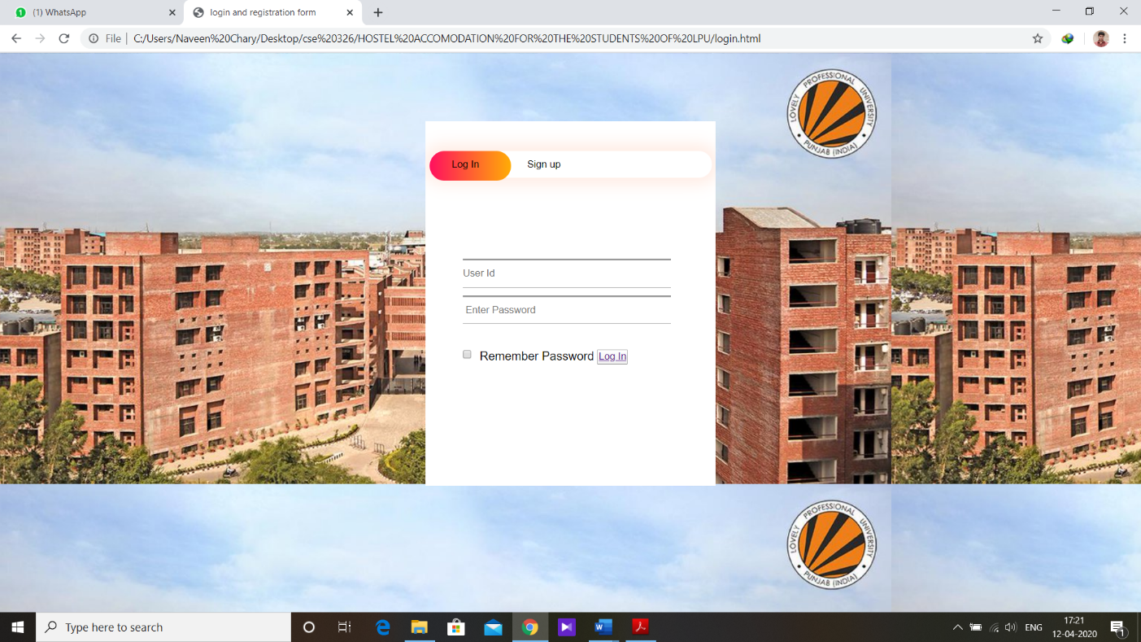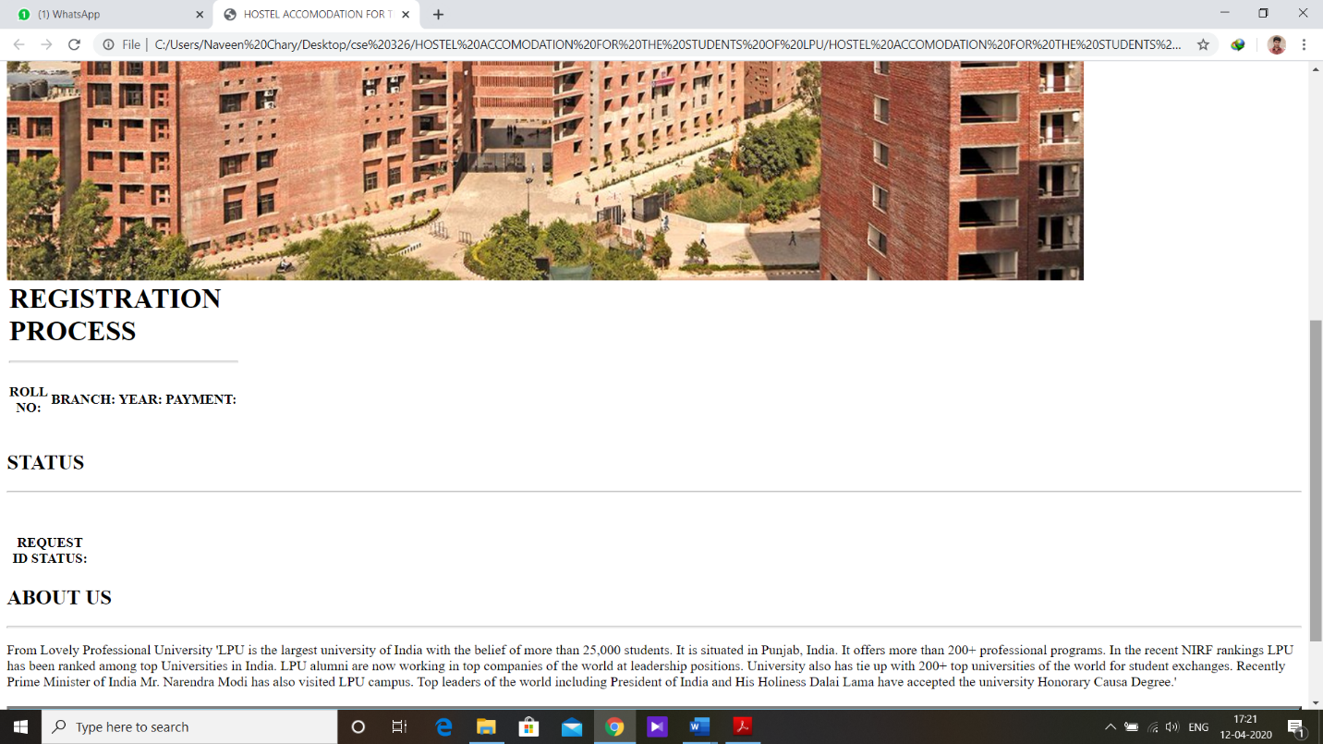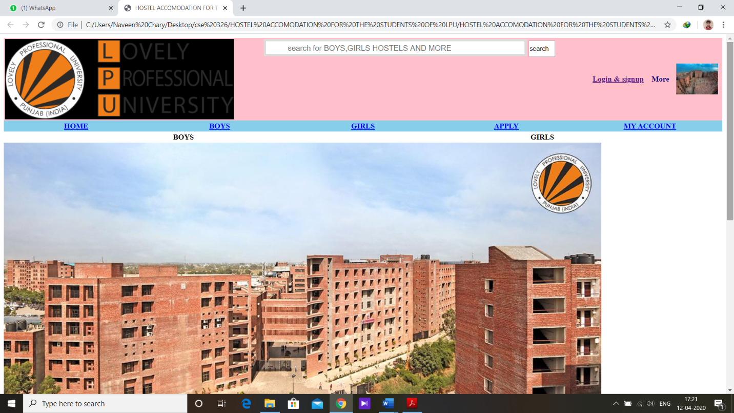

**BIBLIOGRAPHY**

<https://developer.mozilla.org/en-US/docs/Web/HTML/Element/source>

<https://www.yourhtmlsource.com/>

<https://www.webnots.com/view-webpage-source-css-in-google-chrome/>

<https://www.w3schools.com/tags/tag_source.asp>

<https://www.w3.org/Style/Examples/011/firstcss.en.html>

<https://thenextscoop.com/web-design-techniques-2018/>

<https://pagely.com/blog/web-design-development-tools/>

<https://www.webfx.com/blog/web-design/6-advanced-javascript-techniques-you-should-know/>

<https://developer.mozilla.org/en-US/docs/Learn/Getting_started_with_the_web/JavaScript_basics>

<https://blog.hubspot.com/marketing/web-design-html-css-javascript>

<https://html.com/javascript/>